OVERVIEW OF PROJECT CLOSEOUT

Purpose
Closeout is the phase of a project where the physical work and administrative duties are completed. The amount of time needed to close out a project can be as much as, and may be more than, the time to initiate all of the commitments in the project. As a vital part of project management, a thorough project closeout protects against potential risks by establishing accountability for maintenance and warranties. A successful closeout is characterized by timely submittals, accurate accounting, complete documentation, and a well-run, occupied facility.
Excessive delays in project closeout have negative consequences. Unspent funds cannot be reallocated to other projects. Funding sunsets and other legislative restrictions can result in projects losing money if appropriations are not spent and closed within specific timelines. Additionally, Minnesota State could lose credibility with the state legislature for future capital budget requests.

Definitions
Contingency (Owner’s). A portion of a funding source within e-Builder, which is separate from commitments, which may be used at the Owner’s discretion. Funds may be used to pay for Change Orders or other costs associated with the project.
Final Completion. The date when all punchlist items are addressed, all other remaining contractual requirements are completed, and the final application for payment is processed.
Final Payment. The very last payment to the contractor that releases all of the retainage.
Punchlist. A comprehensive list of items attached to the Certificate of Substantial Completion to be completed or corrected by the General Contractor (along with the associated value) prior to final payment.
Post Occupancy occurs after project is completed and closed out. For projects that are required to follow B3/Minnesota Stainability Guidelines, a Post Occupancy Evaluation is conducted by B3 staff typically 9 months after Final Completion.
Retainage. A percentage of the value of the construction contract that is withheld from progress payments until all conditions of the contract have been met. Retainage is money due to the Contractor for work performed. Retainage is also a financial incentive to the Contractor to complete the project according to the contract documents.
During the contract execution, the project manager must establish the retainage percentage. Per Minnesota Statute §15.72, the maximum amount of retainage may not exceed five percent. E-Builder automatically calculates the amount in the application for payment. Retainage is essentially held in escrow within e-Builder. Retainage does not earn interest, cannot be released until certain contract conditions are satisfied, and is not available for claims or additional work.
Substantial Completion. The date when, as certified in writing by the Architect, a project is sufficiently complete, in accordance with the construction contract documents, so that the space may be used for its intended purpose.

Process
The stages of the closeout phase include Substantial Completion, Final Completion, and Post Occupancy.

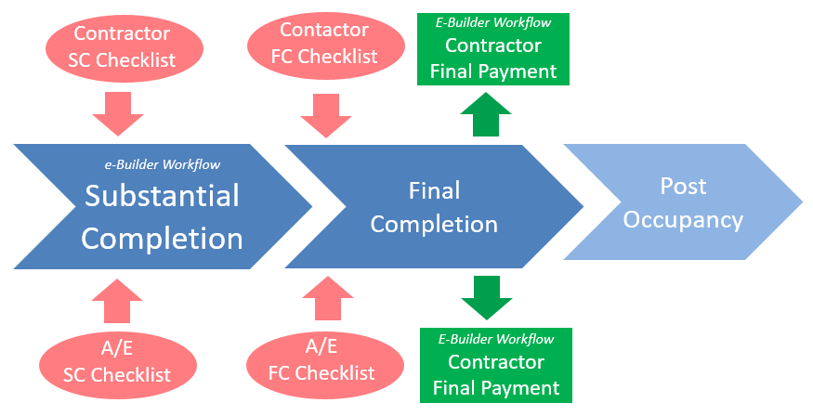

Financial Management
Good financial management will help smooth the project’s transition through close-out. The PM should be actively reviewing consultants’ invoices and other commitments for accuracy and clearly understand the financial status in e-Builder.
Projects benefit from running reconciliation reports earlier and more frequently to catch minor errors before becoming major problems during closeout. Early detection and correction of errors ensures that adequate time and funding will be available for later Proposal Requests.

Contract Changes
One of the biggest periods of risk in a project is during in the final push to occupy the space. Contract changes can be executed against any remaining Owner contingency but not against the retainage. Last minute PR’s and CCD’s are at risk for insufficient funding because of unresolved financial errors.

Substantial Completion
Substantial Completion is a critical milestone date that:
- Allows the College/University to use the space as originally intended,
- Shifts the building insurance from the Contractor to the College/University, and
- Starts the one-year warranty period.
At Substantial Completion, incomplete work is documented on a punchlist. The Certificate of Substantial Completion is signed and dated by Architect/Engineer (A/E), Contractor and the College/University Campus Project Manager (PM). If the date for Substantial Completion is not achieved by the date established in the contract, formal contract changes must be made to the Contractor and A/E contracts by Change Order and Amendment, respectively, to extend the project schedule.

Partial Release of Retainage
After Substantial Completion, the Contractor may submit a written request for a partial release of retainage per the terms of the contract. Minnesota Statute 15.752, Subd.2, limits the retainage amount to:
- no more than 250 percent of the cost to correct or complete the work documented in the punchlist attached to the Certificate of Substantial Completion and
- up to one percent of the value of the contract or $500, whichever is greater, pending completion and submission of all final paperwork.
If the Owner and A/E determine that the Contractor is not due the requested release of retainage, the Owner must promptly provide a written statement detailing the amount and basis of withholding to the Contractor. Any amounts withheld under limit 1) must be paid within 60 days after completion of the work. Any amounts withheld under limit 2) must be paid within 60 days after submission of all final paperwork.

e-Builder Substantial Completion Process
A Substantial Completion process was created in e-Builder to ensure:
- All parties (A/E, contractor and campus PM) sign the Certificate of Substantial Completion
- Single punchlist is attached to process
- All work is completed as detailed in Contractor and A/E checklists

Preparation
Prior to the A/E starting the Substantial Completion process, these documents are uploaded into e-Builder:
Document  Source | Document Name | Who Uploads  Document | e-Builder  Folder
AHJ | Certificate of Occupancy | Contractor | 11.01.02
Contractor | Warranties | Contractor | 11.03
Manufacturer | O&M Manuals | Contractor | 11.02
Contractor | List of Attic Stock | Contractor | 11.08
eManual CO.23 eManual CO.34 | Prevailing Wage | Contractor | 8.12
eManual PC.20 | Contractor Substantial Completion Checklist:  Noting completion of each item, sign/date | Contractor | 11.01.03
eManual PC.21 | A/E Substantial Completion Checklist:  Noting completion of each item, sign/date | A/E | 11.01.03

Documentation
These documents are uploaded as an attachment during the Substantial Completion process:
Document  Source | Document Name | Who Uploads  Document | e-Builder  Folder
AIA G704 or approved document | Certificate of Substantial Completion | A/E | 11.01
A/E form | Punchlist (combine all punchlists into a single document) | A/E | 11.01
eManual PC.20 | Contractor Substantial Completion Checklist | A/E | 11.01.03
eManual PC.21 | A/E Substantial Completion Checklist | A/E | 11.01.03

Campus PM are encouraged to schedule the 10 month warranty walk-through once Substantial Completion is achieved.

Final Completion
After the work identified on the punchlist is complete, along with other contractual requirements, Final Completion occurs. Within e-Builder, the final application for payment is best understood as two separate application processes. The next to the last application pays for the balance of the material and labor and any outstanding change orders, however, it is still considered a partial payment application (indicate “P” in e-builder process). The actual last and final application for payment only releases retainage (indicate “F” in e-builder process). PM's shouldn't approve 100% payment against the value of "the work" if there are any outstanding PR's or CCD's.

Contractor’s Final Application for Payment with Release of Retainage

Preparation
These documents are uploaded into e-Builder prior to the Contractor starting the application for payment process:
Document  Source | Document Name | Who Uploads Document | e-Builder  Folder
A/E CAD Files | Record Documents:  Includes CO & Contractor’s redlines | A/E
Dept of Revenue | Release of Claims IC 134s | Contractor | 11.04
Surety Notice | Consent of Surety | Contractor | 11.06
Contractor | Testing & Balancing, Commissioning | Contractor | 11.07
A/E form | Punchlist:  Contractor noting completion of each item | Contractor | 11.01.01
eManual PC.30 | Contractor Final Completion Checklist:  Noting completion of each item | Contractor | 11.01.03
eManual PC.31 | A/E Final Completion Checklist:  Noting completion of each item | A/E | 11.01.03

Documentation
These documents are uploaded during the final Application for Payment process:
Document  Source | Document Name | Who Uploads Document | e-Builder  Folder
AIA G702 | Final Pay Application | Contractor | 04.04.03
eManual PC.30 | Contractor completed (signed/dated) Final Completion Checklist | Contractor | 11.01.03

Final Invoice A/E
The final invoice from the A/E is submitted after certifying the final payment (release of retainage) to the Contractor.

Documentation
When the A/E submits their final invoice, these documents are attached to the process and automatically placed in specific e-Builder folder:
Document  Source | Document Name | Who Uploads Document | e-Builder  Folder
CC.60 | Final Invoice Payment Request | A/E | 04.01.03
eManual PC.31 | A/E completed (signed/dated) Final Completion Checklist | A/E | 11.01.03

Financial Reconciliation

Request a Reconciliation Report
Financial reconciliation between e-Builder and ISRS is necessary to close all project commitments. Project managers can request the Facilities Program Budget Officer to run a reconciliation report through EPM11. With this report, the budget officer can identify for the PM which transactions need attention.

Projects with campus funds must run a reconciliation report prior to fiscal year close.

Reconciliation reports can be run at any time but are recommended no later than Substantial Completion. Solving reconciliation issues may require involving the business office or the project manager or possibly both.

Reduce All Commitments to Zero
Project managers are advised to run the Balances by PO and the Funding Source Uncommitted Balance reports in e-Builder to see the remaining balance and available resources. Check encumbrances by PO by running an Open Commitments report in ISRS (ask business office). Ideally, the reports match. For those commitments without a zero balance, project managers should contact each vendor and request a final invoice be sent within a reasonable amount of time (typically 30 days).

After all (final) invoices are processed, commitments without a zero balance must be reduced to zero, such as unused A/E reimbursable expenses or testing agency fees. One way is to use an EADJ process to reduce the PO balance only if the balance exists in both e-Builder and ISRS. If the balance only exists in e-Builder, do a manual commitment change to zero out the PO. The manual commitment change will not interface with ISRS. For additional guidance, refer to the reconciliation report and work closely with the budget officer and e-Builder manager for specific instructions.

Resolve All Processes
Project managers should resolve all processes in e-Builder where all pending processes are moved to the Finish step for example, unaccepted Proposal Requests (PR) or submittal processes through to acceptance. If necessary, the project manager may use the Workflow Override to void the process and move it to the Finish step. PM’s also have the ability to take action on every step in the process until it reaches the Finish step.

The last process in e-Builder is closeout (CLO) initiated by the campus project manager. This process alerts the budget officer to run a 521 Trial Balance Report that verifies all balances and commitments are resolved and aligned in both e-Builder and ISRS. If the project has unused HEAPR funds, the budget officer “sweeps” the funds back to the system office HEAPR reserve. After confirming alignment, the budget office approves the closeout process. For campus funds, project managers must inform their business office that the project is closed and ask to pull back remaining funds (reduce the budget in ISRS). Once the CLO process is completed, the status of the project will switch from “Active” to “Complete” and financial transactions are no longer possible.

Post Occupancy
Accurate project details within the e-Builder Details module are essential for system-wide reporting. Project managers should update or correct specific data fields at close-out such as Project Phase, Facility Financial Type, Square Footage, and Construction Bid Award, among others.

Starting in 2020, capital projects are encouraged to conduct a Post-Occupancy Project (POP) Review with A/E, Contractor, campus Project Manager, occupants of the space, facilities maintenance staff, and system office. This evaluation will provide beneficial feedback for vendors, campus staff, and system office.

After occupancy, these documents are uploaded into e-Builder as they occur:
Document  Source | Document Name | Who Uploads Document | e-Builder  Folder
A/E | Ten Month Inspection | A/E | 12.01
eManual CO.62 | Post-Occupancy Project (POP) Review survey | Campus PM | 12.02
B3 | B3 POES (if applicable) | Campus PM | 12.02

